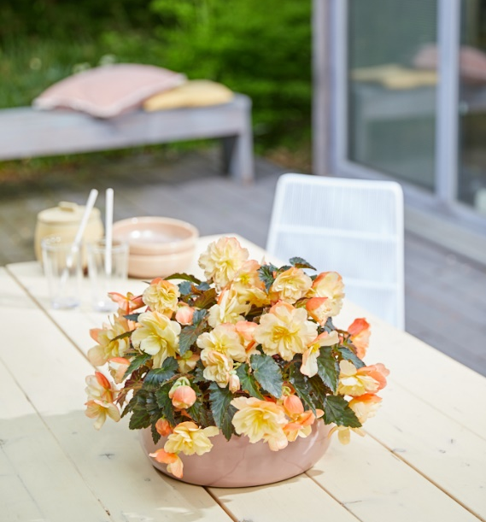

SCORE SHEET FLEUROSTAR CONTEST
Entry : Begonia hybrida
I'CONIA Aroma Peach
Entrant : Dümmen Orange
Type : Cutting

Begonia hybrida I'CONIA Aroma Peach is the new scented Begonia from Dümmen Orange. Over the years breeding has often excluded fragrance in favour of other traits, but this new hybrid Begonia has brought aroma back on the agenda. Of course, the breeder has not overlooked beauty. These luxurious double flowers in plush peach have a strong garden performance and are non-stop flowering for gorgeous planters and beautiful baskets.
The I'CONIA series from Dümmen Orange continues to portray the pinnacle of modern Begonias with shade to part-sun tolerance, excellent retail flower-power and noted consumer performance.

I'CONIA Aroma Peach, the sweet smell of sumptuousness.

NAME OF JUDGE : ______________________________________________

ENTRIES VIEWED:
- Online
- At Florensis
- At Syngenta Flowers

SCORING:

A. How do you rate this variety on Point of Sale Attractiveness 1 2 3 4 5
(Rate on point-of-sale attractiveness where 1 is the lowest rating and 5 is the highest)

B. How do you rate this variety on Commercial Potential 1 2 3 4 5
(Rate on commercial potential where 1 is the lowest rating and 5 is the highest)

C. Does this variety deserve to win the FleuroStar? YES / NO (please circle)
(A FleuroStar winner is an innovation which is able to arouse the interest of the retailer and consumer due to its beauty, expressiveness and exceptional quality i.e. its ‘’Wow” factor)

3. COMMENTS IN SUPPORT OF SCORING:
____________________________________________________________________________________
____________________________________________________________________________________
____________________________________________________________________________________
____________________________________________________________________________________
____________________________________________________________________________________

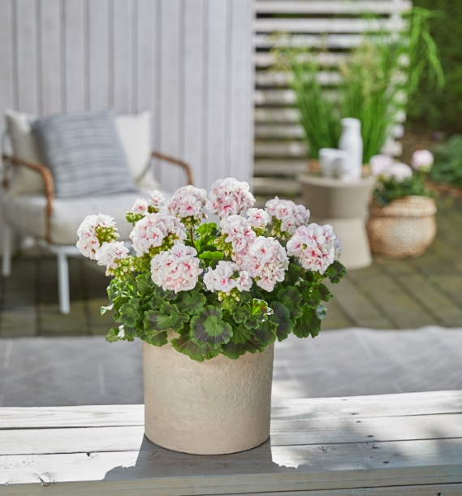

SCORE SHEET FLEUROSTAR CONTEST
Entry : Pelargonium zonale
Estelle Appleblossom
Entrant : Florensis
Type : Cutting

Pelargonium zonale Estelle Appleblossom might just become the future queen of the Florensis assortment. Named after the Swedish princess Estelle, this introduction is the perfect plant to create that typical Scandinavian style in harmonizing Appleblossom. Estelle Appleblossom stands out with a full flowering rounded plant habit, medium green leaves, and good zonal markings.
It is central flowering with an abundance of double flowers that last long in both retail and the garden. From Toscana breeding, Estelle Appleblossom never fails to perform and is easy to produce in 12-13 cm pots.

Estelle Appleblossom, for stylish Scandinavian living

NAME OF JUDGE : ______________________________________________

ENTRIES VIEWED:
- Online
- At Florensis
- At Syngenta

SCORING:

A. How do you rate this variety on Point of Sale Attractiveness 1 2 3 4 5
(Rate on point-of-sale attractiveness where 1 is the lowest rating and 5 is the highest)

B. How do you rate this variety on Commercial Potential 1 2 3 4 5
(Rate on commercial potential where 1 is the lowest rating and 5 is the highest)

C. Does this variety deserve to win the FleuroStar? YES / NO (please circle)
(A FleuroStar winner is an innovation which is able to arouse the interest of the retailer and consumer due to its beauty, expressiveness and exceptional quality i.e. its ‘’Wow” factor)

3. COMMENTS IN SUPPORT OF SCORING:
____________________________________________________________________________________
____________________________________________________________________________________
____________________________________________________________________________________
____________________________________________________________________________________
____________________________________________________________________________________

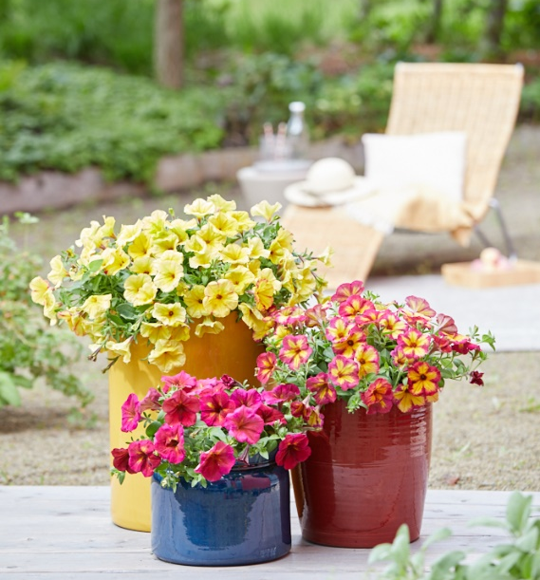

SCORE SHEET FLEUROSTAR CONTEST
Entry : Petunia x hybrida
Fun House Potpourri
Entrant : Syngenta Flowers
Type : Cutting

With Petunia Fun House Potpourri, Syngenta Flowers has exceeded the ordinary. This variety is a colour changing member of the new Fun House family of extraordinary Petunias, each with a unique colour, unusual pattern or exciting shape. Potpourri’s flowers change colour depending on climatic variation: while little light and low temperature will give rose-red colours, higher temperatures and full sun will lead to solid yellow flowers.
This unique Petunia will surely stand out on the benches at point of sale and the consumer can experience the excitement of numerous colour variations ranging from clear warm yellow to rose yellow-star to almost solid rose, all in one season. Potpourri turns every basket, container or flower bed into something special.

Fun House Potpourri, for an extraordinary garden

NAME OF JUDGE : ______________________________________________

ENTRIES VIEWED:
- Online
- At Florensis
- At Syngenta

SCORING:

A. How do you rate this variety on Point of Sale Attractiveness 1 2 3 4 5
(Rate on point-of-sale attractiveness where 1 is the lowest rating and 5 is the highest)

B. How do you rate this variety on Commercial Potential 1 2 3 4 5
(Rate on commercial potential where 1 is the lowest rating and 5 is the highest)

C. Does this variety deserve to win the FleuroStar? YES / NO (please circle)
(A FleuroStar winner is an innovation which is able to arouse the interest of the retailer and consumer due to its beauty, expressiveness and exceptional quality i.e. its ‘’Wow” factor)

3. COMMENTS IN SUPPORT OF SCORING:
____________________________________________________________________________________
____________________________________________________________________________________
____________________________________________________________________________________
____________________________________________________________________________________
____________________________________________________________________________________
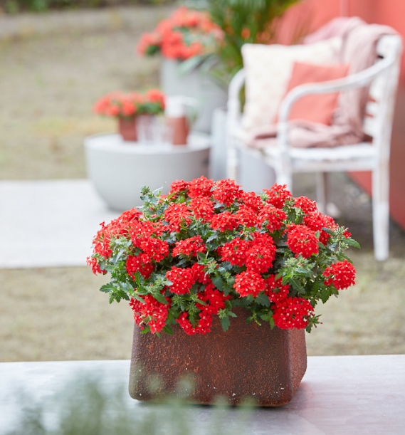
SCORE SHEET FLEUROSTAR CONTEST
Entry : Verbena
Mr. LavaLava
Entrant : Selecta one
Type : Cutting

Mr. LavaLava is the singer in Selecta one’s new Verbena big band. He has taken his stage name from the smouldering magma as it erupts from the volcano and that is just what this variety does. The vibrant orange-red flowers creep and spread across the garden bringing an outburst of spectacular ground coverage. Of course, this also makes them suitable for hanging baskets and hot container combinations.
This new Verbena’s fiery flowers stand out visually and like a true artist the plants perform continuously without a break remaining strong from spring to first frosts.

Mr. LavaLava: cool performer, hot Verbena!

NAME OF JUDGE : ______________________________________________

ENTRIES VIEWED:
- Online
- At Florensis
- At Syngenta

SCORING:

A. How do you rate this variety on Point of Sale Attractiveness 1 2 3 4 5
(Rate on point-of-sale attractiveness where 1 is the lowest rating and 5 is the highest)

B. How do you rate this variety on Commercial Potential 1 2 3 4 5
(Rate on commercial potential where 1 is the lowest rating and 5 is the highest)

C. Does this variety deserve to win the FleuroStar? YES / NO (please circle)
(A FleuroStar winner is an innovation which is able to arouse the interest of the retailer and consumer due to its beauty, expressiveness and exceptional quality i.e. its ‘’Wow” factor)

3. COMMENTS IN SUPPORT OF SCORING:
____________________________________________________________________________________
____________________________________________________________________________________
____________________________________________________________________________________
____________________________________________________________________________________
____________________________________________________________________________________

